**JSON with java**

## 1- What is JSON?

JSON (JavaScript Object Notation) is a data-structured text, its elements are a pair of keys and values, its value could also be another element (key & value),  values can also be an array.

Ex1: JsonObject

{

"count": 2,

"completioncodes": [

{

"completionCode": "custom_code1",

"count": 10,

"answerMachineByAgent": false,

"completionCodeType": 1,

"rpc": true,

"success": true,

"closure": true

},

{

"completionCode": "Desktop_Error",

"count": 1,

"answerMachineByAgent": false,

"completionCodeType": 0,

"rpc": false,

"success": false,

"closure": false

}

]

}

With POM project, json object appears when use rest webservice,…

## 2- JSON Libraries

There are many open source Java libraries which help you to parse the Json data. Below is a list of library like so:

* json.org
* Jackson
* **Google GSON**
* json-lib
* javax json
* json-simple
* json-smart
* flexjson
* fastjson

In POM project uses google GSON (com.google.gson).

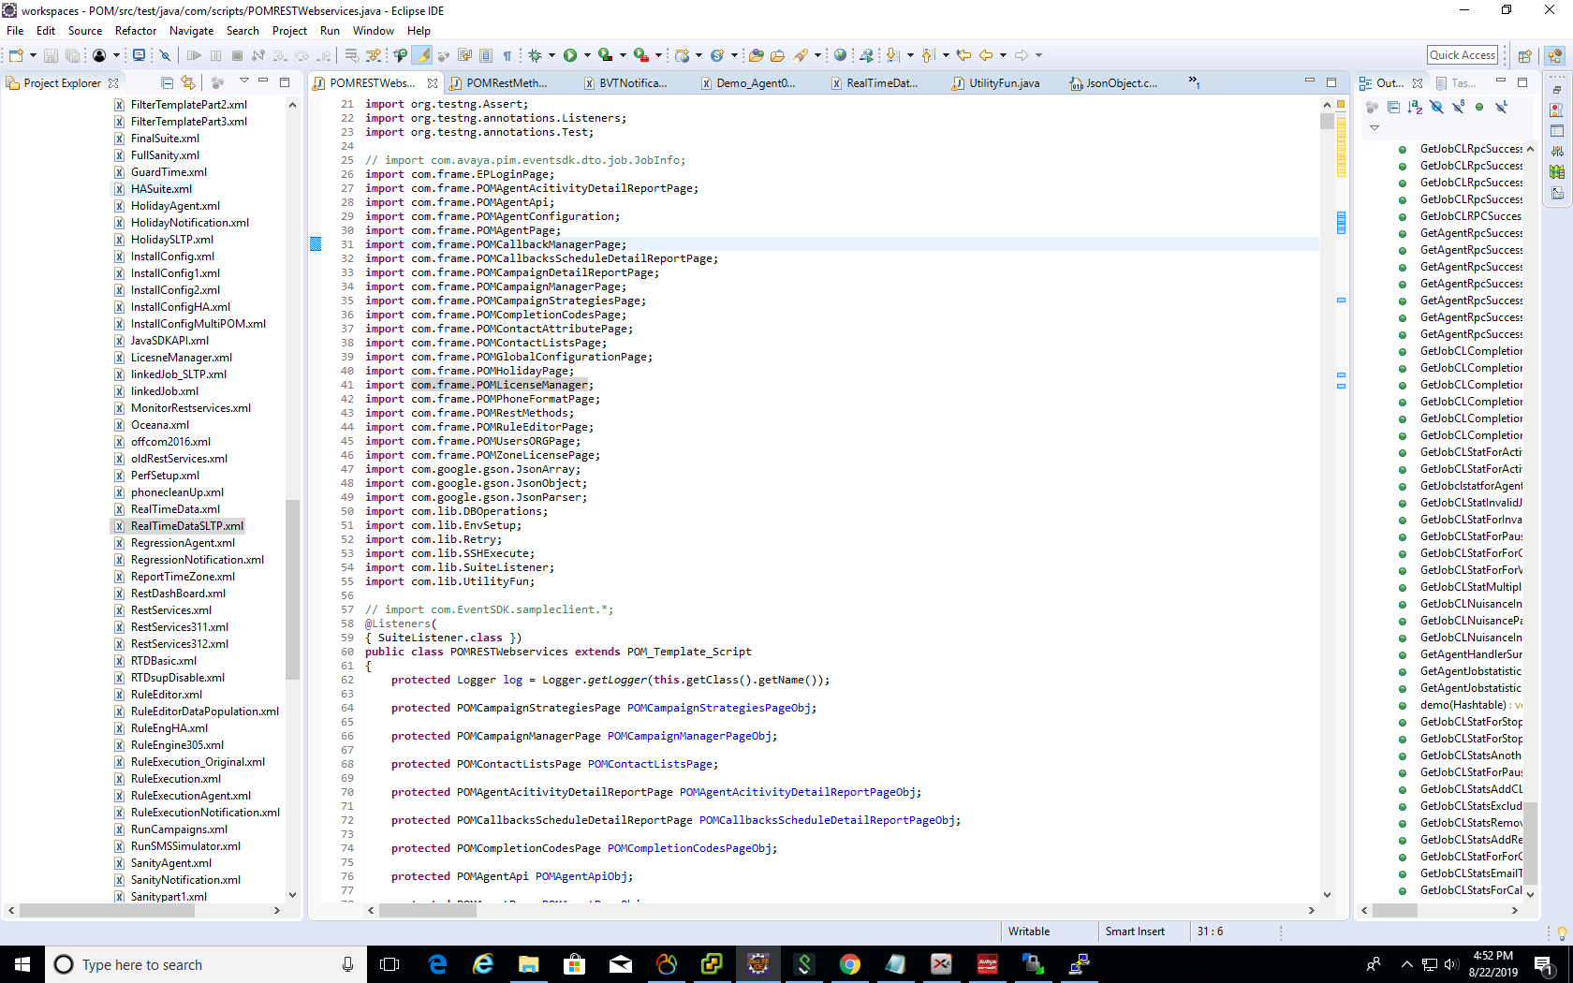Ex2:

### **Some json data types**

(ref: <https://www.w3schools.com/js/js_json_datatypes.asp>)

Ex3:

**Json Array**

[

{ "type": "home", "number": "212 555-1234" },

{ "type": "fax", "number": "646 555-4567" }

]

**Json Object**

{

"count": 2,

"completioncodes": [

{

"completionCode": "custom_code1",

"count": 10,

"answerMachineByAgent": false,

"completionCodeType": 1,

"rpc": true,

"success": true,

"closure": true

},

{

"completionCode": "Desktop_Error",

"count": 1,

"answerMachineByAgent": false,

"completionCodeType": 0,

"rpc": false,

"success": false,

"closure": false

}

]

}

* Get JsonArray from JsonObject:

JsonObject resultJobList = POMRestMethodsObj.getJoblist("jobId", "asc", "", "", "");

JsonArray jobstate1 = (JsonArray) resultJobList.get("jobStat");

## 3- Json in POM project

(ref: <https://static.javadoc.io/com.google.code.gson/gson/2.6.2/com/google/gson/package-tree.html>)

In POM project we can see json data when use rest web service.

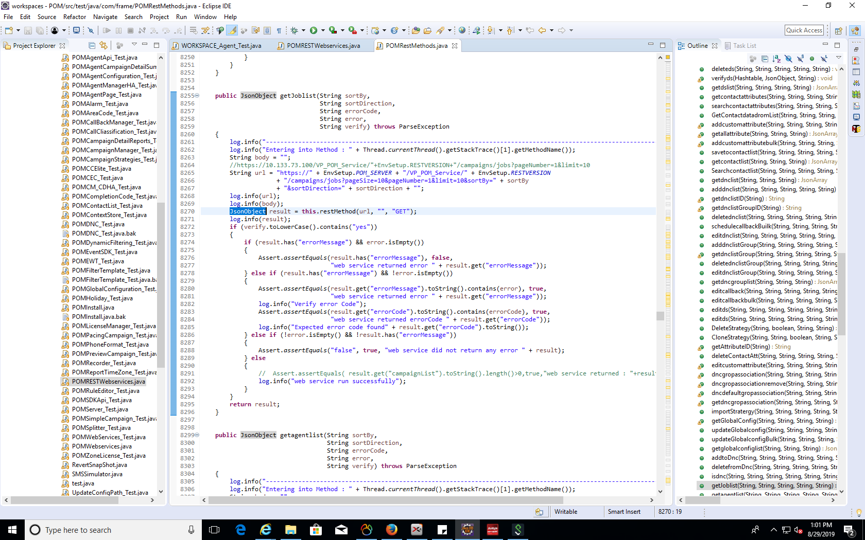Ex4:

Use rest webservice with GET method will return “result” as **JsonObject**.

Some methods in gson.JsonArray, gson.JsonObject, gson.JsonParser are used in POM project

### **JsonObject**

|  |  |
| --- | --- |
| **Modifier and Type** | **Method and Description** |
| [JsonElement](https://static.javadoc.io/com.google.code.gson/gson/2.6.2/com/google/gson/JsonElement.html) | [get](https://static.javadoc.io/com.google.code.gson/gson/2.6.2/com/google/gson/JsonObject.html#get-java.lang.String-)([String](https://docs.oracle.com/javase/6/docs/api/java/lang/String.html?is-external=true) memberName)  Returns the member with the specified name. |
| void | [addProperty](https://static.javadoc.io/com.google.code.gson/gson/2.6.2/com/google/gson/JsonObject.html#addProperty-java.lang.String-java.lang.Boolean-)([String](https://docs.oracle.com/javase/6/docs/api/java/lang/String.html?is-external=true) property, [Boolean](https://docs.oracle.com/javase/6/docs/api/java/lang/Boolean.html?is-external=true) value)  Convenience method to add a boolean member. |
| void | [addProperty](https://static.javadoc.io/com.google.code.gson/gson/2.6.2/com/google/gson/JsonObject.html#addProperty-java.lang.String-java.lang.Character-)([String](https://docs.oracle.com/javase/6/docs/api/java/lang/String.html?is-external=true) property, [Character](https://docs.oracle.com/javase/6/docs/api/java/lang/Character.html?is-external=true) value)  Convenience method to add a char member. |
| void | [addProperty](https://static.javadoc.io/com.google.code.gson/gson/2.6.2/com/google/gson/JsonObject.html#addProperty-java.lang.String-java.lang.Number-)([String](https://docs.oracle.com/javase/6/docs/api/java/lang/String.html?is-external=true) property, [Number](https://docs.oracle.com/javase/6/docs/api/java/lang/Number.html?is-external=true) value)  Convenience method to add a primitive member. |
| void | [addProperty](https://static.javadoc.io/com.google.code.gson/gson/2.6.2/com/google/gson/JsonObject.html#addProperty-java.lang.String-java.lang.String-)([String](https://docs.oracle.com/javase/6/docs/api/java/lang/String.html?is-external=true) property, [String](https://docs.oracle.com/javase/6/docs/api/java/lang/String.html?is-external=true) value)  Convenience method to add a primitive member. |
| [JsonElement](https://static.javadoc.io/com.google.code.gson/gson/2.6.2/com/google/gson/JsonElement.html) | [remove](https://static.javadoc.io/com.google.code.gson/gson/2.6.2/com/google/gson/JsonObject.html#remove-java.lang.String-)([String](https://docs.oracle.com/javase/6/docs/api/java/lang/String.html?is-external=true) property)  Removes the property from this [JsonObject](https://static.javadoc.io/com.google.code.gson/gson/2.6.2/com/google/gson/JsonObject.html). |

Ex5:

**JsonObject** result = **null**;

result = POMRestMethodsObj.getcontact(listname[1], "", "", ids.get(i));

result.**remove**("contactListName");

result.**addProperty**("automaticUpdateTimezone", "false");

POMRestMethodsObj.SaveContactToList(listname[0], "", "", **result.toString()**);

JsonArray customobject = (JsonArray) **result.get**("customAttributeList");

### **JsonArray**

|  |  |
| --- | --- |
| **Modifier and Type** | **Method and Description** |
| void | [add](https://static.javadoc.io/com.google.code.gson/gson/2.6.2/com/google/gson/JsonArray.html#add-com.google.gson.JsonElement-)([JsonElement](https://static.javadoc.io/com.google.code.gson/gson/2.6.2/com/google/gson/JsonElement.html) element)  Adds the specified element to self. |
| [JsonElement](https://static.javadoc.io/com.google.code.gson/gson/2.6.2/com/google/gson/JsonElement.html) | [remove](https://static.javadoc.io/com.google.code.gson/gson/2.6.2/com/google/gson/JsonArray.html#remove-int-)(int index)  Removes the element at the specified position in this array. |
| [JsonElement](https://static.javadoc.io/com.google.code.gson/gson/2.6.2/com/google/gson/JsonElement.html) | [set](https://static.javadoc.io/com.google.code.gson/gson/2.6.2/com/google/gson/JsonArray.html#set-int-com.google.gson.JsonElement-)(int index, [JsonElement](https://static.javadoc.io/com.google.code.gson/gson/2.6.2/com/google/gson/JsonElement.html) element)  Replaces the element at the specified position in this array with the specified element. |
| int | [size](https://static.javadoc.io/com.google.code.gson/gson/2.6.2/com/google/gson/JsonArray.html#size--)()  Returns the number of elements in the array. |
| [JsonElement](https://static.javadoc.io/com.google.code.gson/gson/2.6.2/com/google/gson/JsonElement.html) | [get](https://static.javadoc.io/com.google.code.gson/gson/2.6.2/com/google/gson/JsonArray.html#get-int-)(int i)  Returns the ith element of the array. |

EX6:

**JsonArray** jobstate1 = (**JsonArray**) resultJobList.get("jobStat");

**for** (**int** i = 0; i < jobstate1.**size**(); i++)

.. ..

JsonObject jobdata = (JsonObject) jobstate1.**get**(i);

### **JsonElement**

|  |  |
| --- | --- |
| **Modifier and Type** | **Method and Description** |
| [JsonArray](https://static.javadoc.io/com.google.code.gson/gson/2.6.2/com/google/gson/JsonArray.html) | [getAsJsonArray](https://static.javadoc.io/com.google.code.gson/gson/2.6.2/com/google/gson/JsonElement.html#getAsJsonArray--)()  convenience method to get this element as a [JsonArray](https://static.javadoc.io/com.google.code.gson/gson/2.6.2/com/google/gson/JsonArray.html). |
| [JsonObject](https://static.javadoc.io/com.google.code.gson/gson/2.6.2/com/google/gson/JsonObject.html) | [getAsJsonObject](https://static.javadoc.io/com.google.code.gson/gson/2.6.2/com/google/gson/JsonElement.html#getAsJsonObject--)()  convenience method to get this element as a [JsonObject](https://static.javadoc.io/com.google.code.gson/gson/2.6.2/com/google/gson/JsonObject.html). |
| boolean | [isJsonNull](https://static.javadoc.io/com.google.code.gson/gson/2.6.2/com/google/gson/JsonElement.html#isJsonNull--)()  provides check for verifying if this element represents a null value or not. |
| [String](https://docs.oracle.com/javase/6/docs/api/java/lang/String.html?is-external=true) | [toString](https://static.javadoc.io/com.google.code.gson/gson/2.6.2/com/google/gson/JsonElement.html#toString--)()  Returns a String representation of this element. |

Ex7:

JsonArray custatt= (JsonArray) result.get("customAttributeList");

**for**(**JsonElement** **resatt** : custatt)

.. ..

JsonObject tmpres = resatt.**getAsJsonObject**();

### **JsonParser**

|  |  |
| --- | --- |
| **Modifier and Type** | **Method and Description** |
| [JsonElement](https://static.javadoc.io/com.google.code.gson/gson/2.6.2/com/google/gson/JsonElement.html) | [parse](https://static.javadoc.io/com.google.code.gson/gson/2.6.2/com/google/gson/JsonParser.html#parse-com.google.gson.stream.JsonReader-)([JsonReader](https://static.javadoc.io/com.google.code.gson/gson/2.6.2/com/google/gson/stream/JsonReader.html) json)  Returns the next value from the JSON stream as a parse tree. |
| [JsonElement](https://static.javadoc.io/com.google.code.gson/gson/2.6.2/com/google/gson/JsonElement.html) | [parse](https://static.javadoc.io/com.google.code.gson/gson/2.6.2/com/google/gson/JsonParser.html#parse-java.io.Reader-)([Reader](https://docs.oracle.com/javase/6/docs/api/java/io/Reader.html?is-external=true) json)  Parses the specified JSON string into a parse tree |
| [JsonElement](https://static.javadoc.io/com.google.code.gson/gson/2.6.2/com/google/gson/JsonElement.html) | [parse](https://static.javadoc.io/com.google.code.gson/gson/2.6.2/com/google/gson/JsonParser.html#parse-java.lang.String-)([String](https://docs.oracle.com/javase/6/docs/api/java/lang/String.html?is-external=true) json)  Parses the specified JSON string into a parse tree |

Ex8:

**JsonParser** **parser** = **new** JsonParser();

JsonArray array = (JsonArray)parser.**parse**("["+

testData.get("filterCriteriaAttributeList").toString()+ "]");

array = (JsonArray) parser.**parse**("["+ testData.get("allSortAttrList").toString() +"]");

Reference

<https://o7planning.org/en/10437/java-json-processing-api-tutorial>

<https://docs.oracle.com/javaee/7/api/index.html>

<https://www.w3schools.com/js/js_json_datatypes.asp>

<https://static.javadoc.io/com.google.code.gson/gson/2.6.2/com/google/gson/package-tree.html>